This is a population problem, not a sample mean problem, so I will find the Z scores for total cholesterols of 180 and 190, and I will use either the table or R to find the areas to the left.
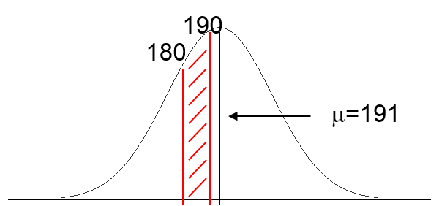
I will then subtract the probability for 180 from the probability for 190 to find the area (probability) in between.

For 180: $Z=\frac{x-μ}{σ}=\frac{180-191}{22.4}= -0.49$
In R:
> pnorm(-0.49)
[1] 0.3120669

P(Z<180)= 0.312

For 190: $Z= \frac{190-191}{22.4}= -0.04$
In R:
> pnorm(-0.04)
[1] 0.4840466

P(Z< -0.04) = 0.484

P(180<X<190) = 0.484-0.312 = 0.172
In this population the probability of a total cholesterol between 180-190 is 0.172 or 17.2%.

